Customer Onboard Issues

1. **Issue:**  
   The customer has been onboarded in Salesforce, customer account sync successfully and the site was manually created in Fusion, but there is no Salesforce ID.
2. **Teams Involved:**  
   SFDC, Fusion, Intern, Business
3. **Steps to Take:**
   1. **Notify EP_EECI On-call or SFDC Team**: Inform the team responsible for creating the site in SFDC. Once the site is created, provide the Salesforce Site ID to the Business team for updating in Fusion.
      * Fix the "Bill to Flag Address" for the account in SFDC.
      * Provide the SFDC Address ID to Rhonda & Jonathan for updating in Fusion.
   2. **Notify Business Team**: Update the Salesforce Site ID in Fusion.
      * Contact: Rhonda Duff or Jonathan Faulkner
      * Return the Omega Site ID to the EP_EECI On-call or SFDC Team for updating in SFDC.
      * This will facilitate syncing the billing information to Intern.
   3. **EP_CNC On-cal**l: The Enterprise Engineer updates the Ent CRM with the correct Site ID from Fusion.
      * Update the ENT CRM and inform the Business team.
   4. **Business Team/ Fusion team**:
      * A new record is created in Fusion after updating the Intern/Ent CRM.
      * Rhonda/Jonathan Faulkner should check and delete the record from Fusion.
      * Select the site with an unnecessary address set, end date it, and delete site uses.

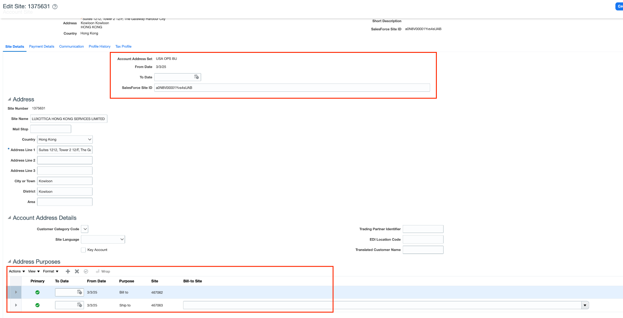

* Delete/wipeoff salesforce site id
* Update To Date same as Form date
* Delete address Purposes

**Example Tasks:**

* [T216333311](https://www.internalfb.com/intern/tasks/?t=216333311): Customer Onboarding - LUXOTTICA HONG KONG SERVICES LTD
* [T212686069](https://www.internalfb.com/intern/tasks/?t=212686069): One Door - RL GSPO Core Solutions Request Form | CONSUMER SFDC | FRL ACCOUNT (ROTO VR LTD UK)

—----------------------------------------------------------------------

2.

1. **Issue:**  
   The customer has been onboarded in Salesforce, but the bill to is not syncing to Fusion

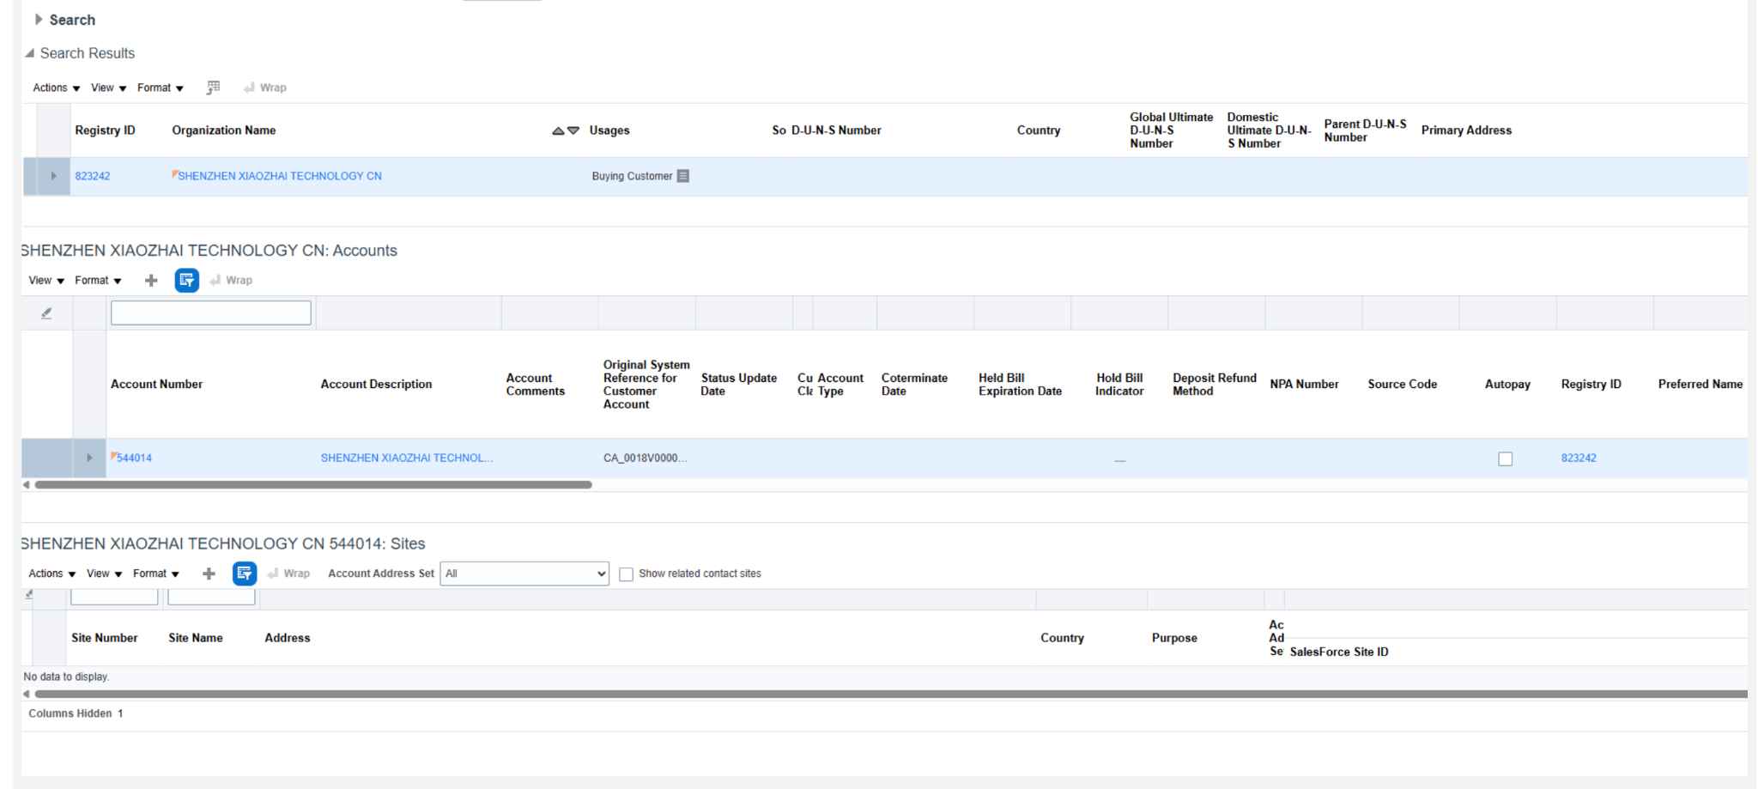

1. **Teams Involved:**  
   SFDC, Fusion, Intern, Business
2. **Steps to Take:**

**1. Notify EP_EECI On-call or SFDC Team**: Inform the team responsible for creating the site in SFDC. Once the site is created it will sync to the customer site in fusion.

* Fix the "Bill to Flag Address" for the account in SFDC.

**2. Notify Business Team**: Update the Salesforce Site ID in Fusion.

* + - Contact: Rhonda Duff or Jonathan Faulkner
    - Return the Omega Site ID to the EP_EECI On-call or SFDC Team for updating in SFDC.
    - This will facilitate syncing the billing information to Intern.

**3. EP_CNC On-cal**l: The Enterprise Engineer updates the Ent CRM with the correct Site ID from Fusion.

* + - Update the ENT CRM and inform the Business team.

**4. Business Team/ Fusion team**:

* + - A new record is created in Fusion after updating the Intern/Ent CRM.
    - Rhonda/Jonathan Faulkner should check and delete the record from Fusion.
    - Select the site with an unnecessary address set, end date it, and delete site uses.
* Delete/wipeoff salesforce site id
* Update To Date same as Form date
* Delete address Purposes

**Example Tasks:**

* [T216150491](https://www.internalfb.com/intern/tasks/?t=216150491) - One Door - RL GSPO Core Solutions Request Form |CONSUMER SFDC | FRL ACCOUNT -SHENZHEN XIAOZHAI TECHNOLOGY CN